Assignment-15.1:

Perform wordcount operation in local mode (In windows environment). Share the code, explain the execution steps, and attach the output screenshot.

Driver Class:

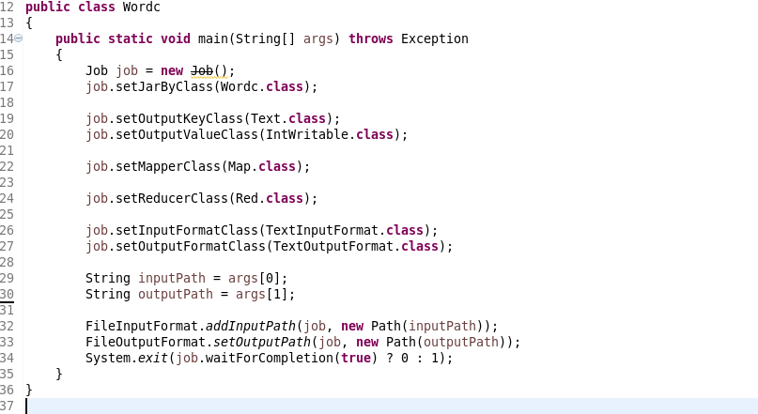

Mapper Class:

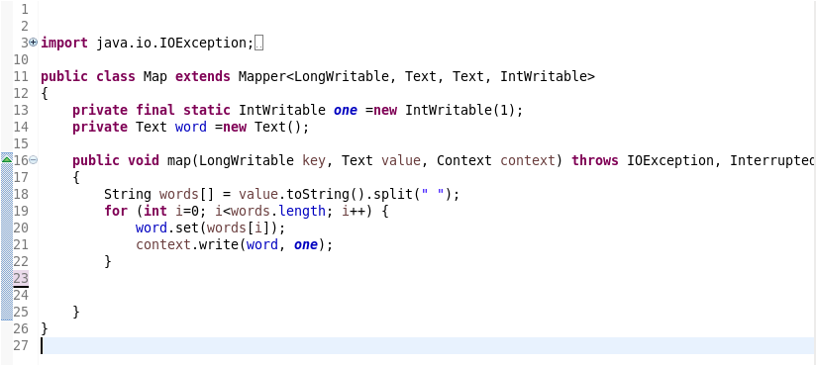

Reducer Class:

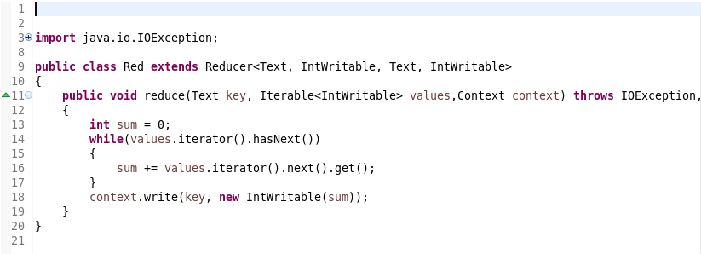

Running the Program as Java Applications:

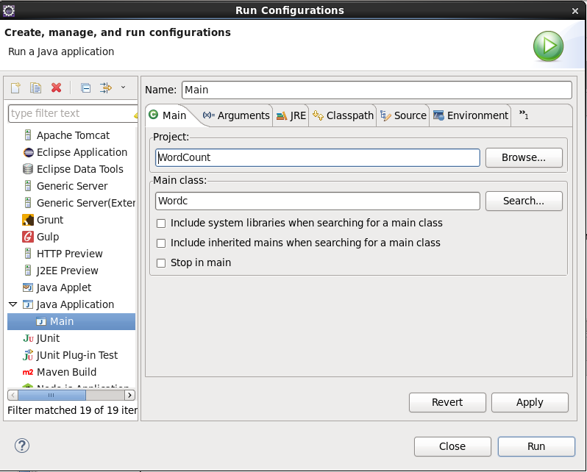

Giving the input and output paths as arguments in the arguments tab:

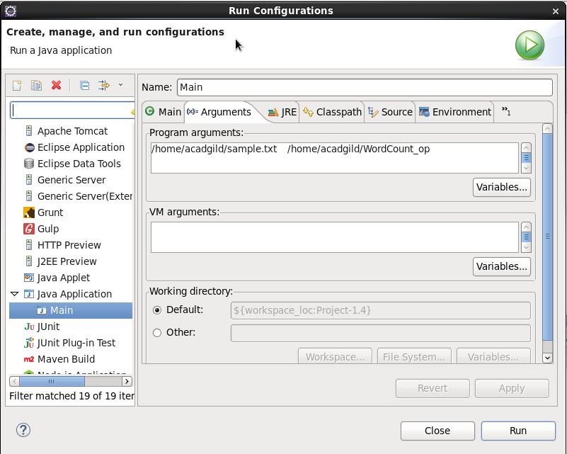

Eclipse Console:

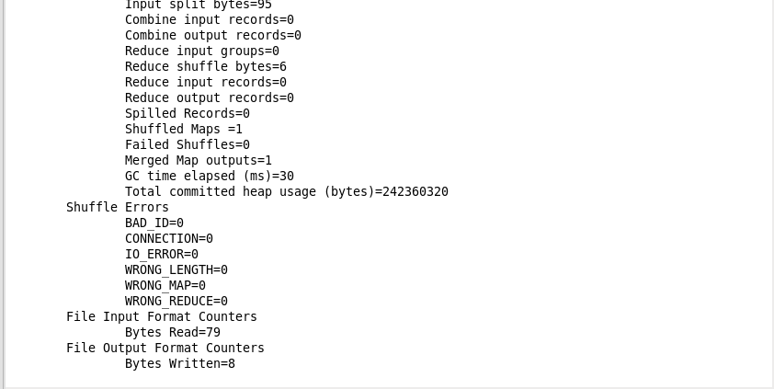

In the above screenshot we can see that the Output is written successfully

Input File:  
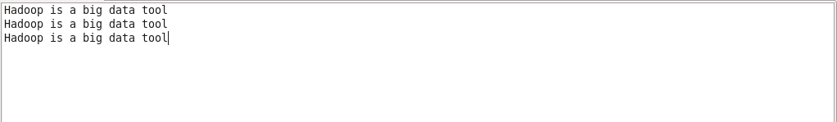

Output File:

